
FATIMA JINNAH WOMEN UNIVERSITY
RAWALPINDI
Department Of Software Engineering

Cloud Computing Lab

Saira Ejaz [2023-BSE-057]

Section: 5-B

LAB NO 5
Lab Task:
Task 1 - Discover missing command & install Java using apt suggestion
Goal: Run the java command when it's not installed, follow the system suggestion to install a Java package using apt, verify, then remove and clear shell cache.
Steps (inside the VM terminal)
- Run the java command to see what the system suggests:
java
Expected: message similar to "The program 'java' can be found in the following packages: ... Try: sudo apt install "
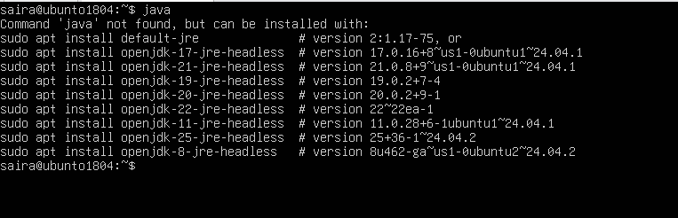
- Use the suggested apt command (copy the exact package name suggested by the system). Example (replace with the name shown on your VM):
sudo apt install <suggested-package> -y
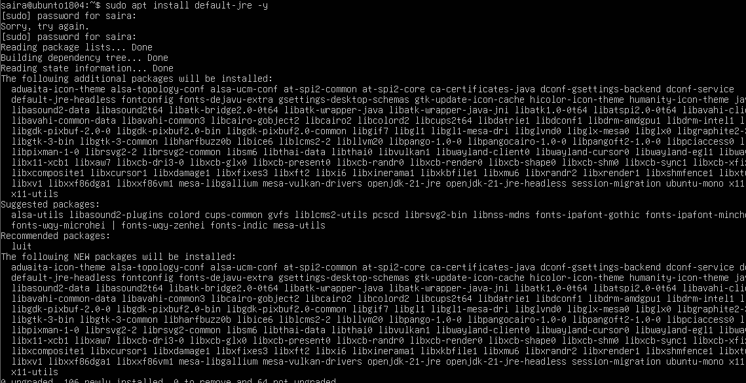
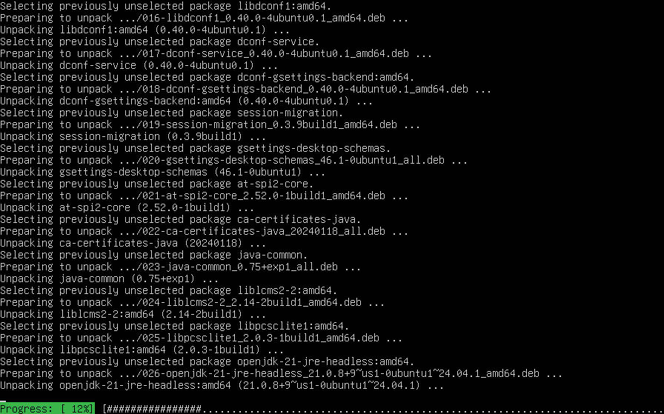
- Verify Java is installed and check version:
java –version
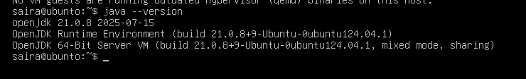
- Remove the Java package using apt remove (use the same package name you installed):
sudo apt remove <suggested-package> -y
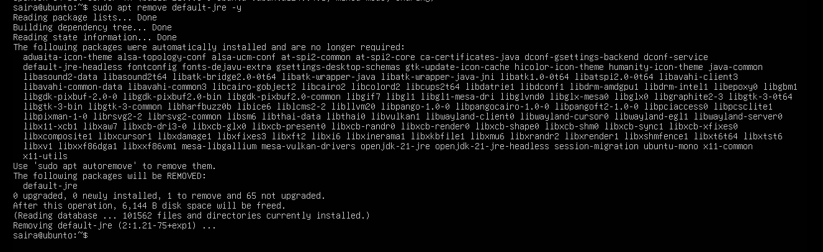
- Confirm java is no longer available (run java again) it should again indicate "not found" or suggest installation:
Java
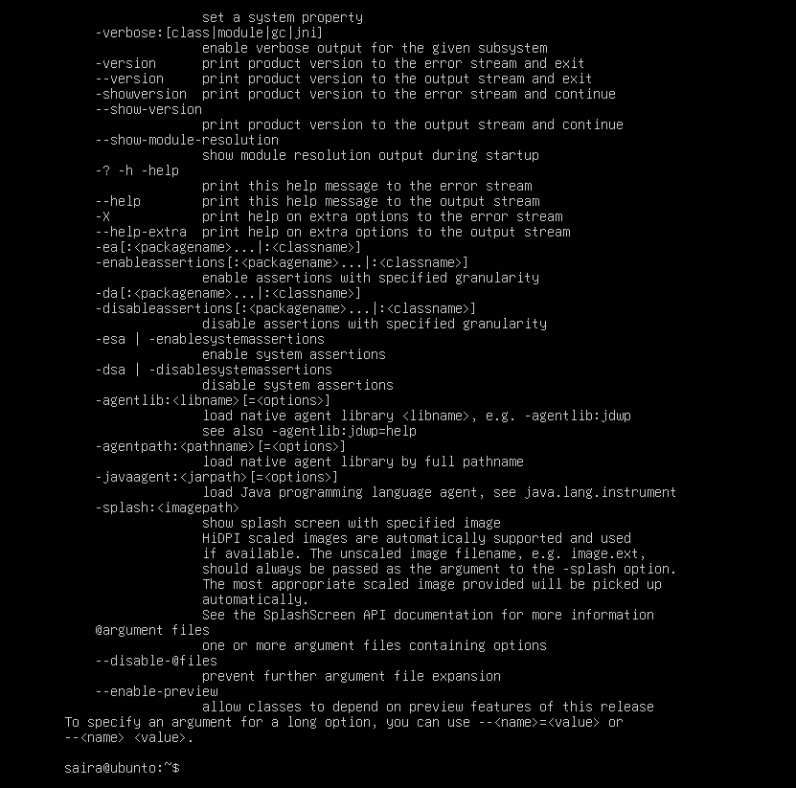
- Clear the shell's command hash cache so the shell forgets cached command locations (run as your regular user — no sudo required):
hash -r
java
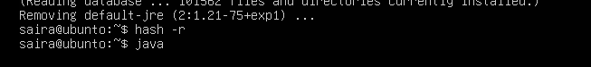
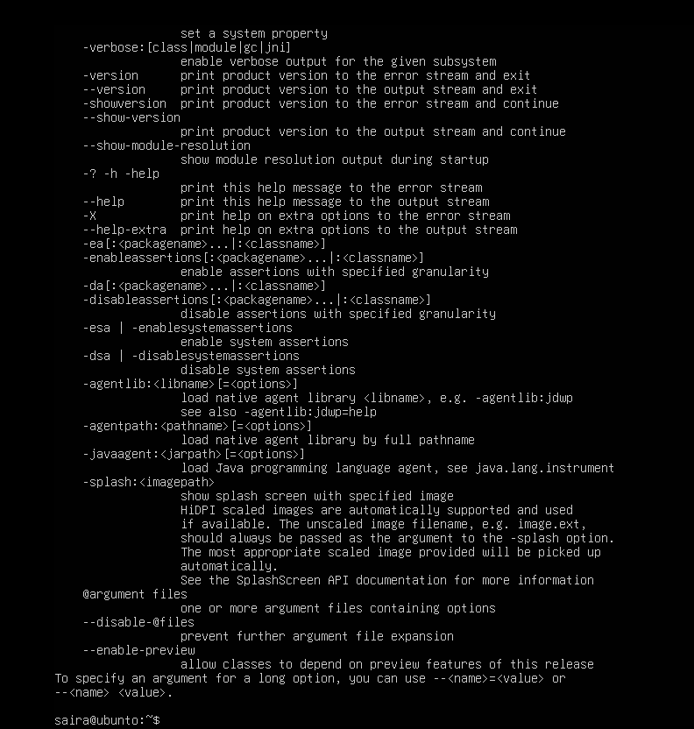
Task 2 - Install & remove Java using apt-get (explicitly)
Goal: Repeat install/remove using the apt-get tool to show both package managers.
Steps (inside VM terminal)
- Install Java using apt-get (choose a common package, e.g., default-jre — or the same package you used in Task 1):
sudo apt-get update
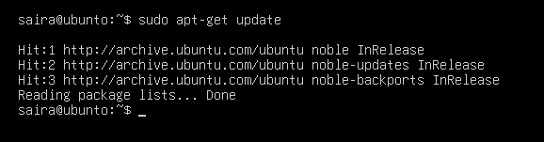
sudo apt-get install default-jre –y
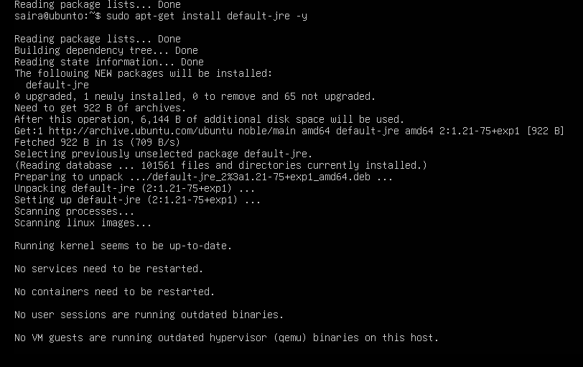
- Verify Java version again:
java –version
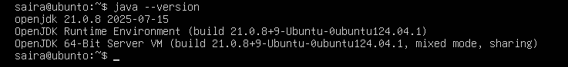
- Remove Java using apt-get remove:
sudo apt-get remove default-jre –y
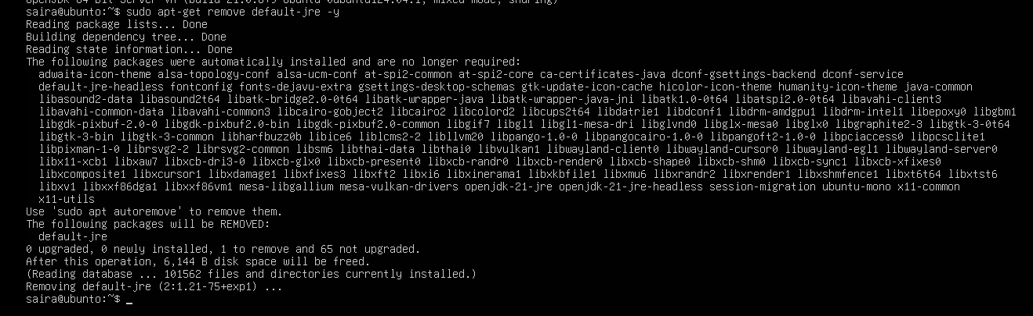
- Clear the terminal hash cache and confirm java is missing:
hash -r
java

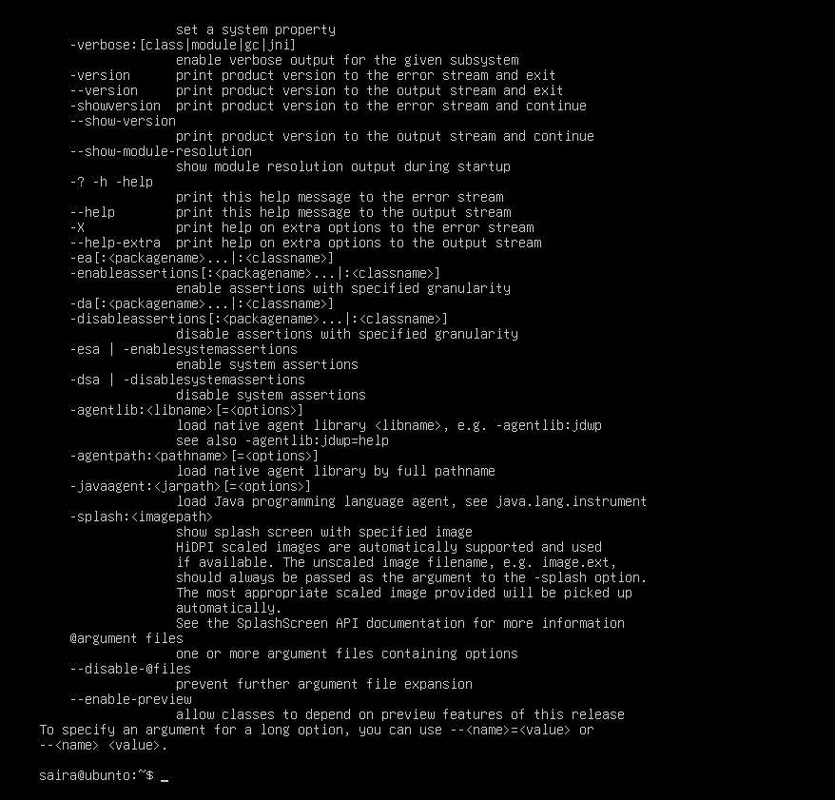
Task 3 - apt update vs apt upgrade - run & explain
Goal: Run the commands and document the difference.
Steps (inside VM terminal)
- Update the package index (this downloads the latest lists of available packages):
sudo apt update
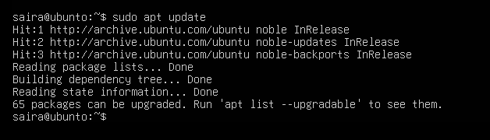
- Upgrade installed packages (this installs available updates for currently installed packages):
sudo apt upgrade
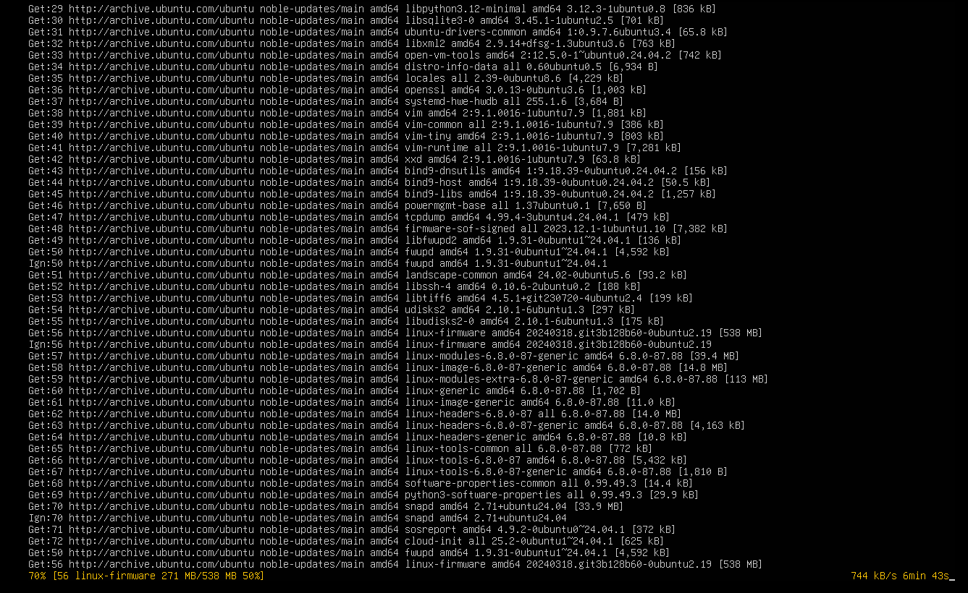
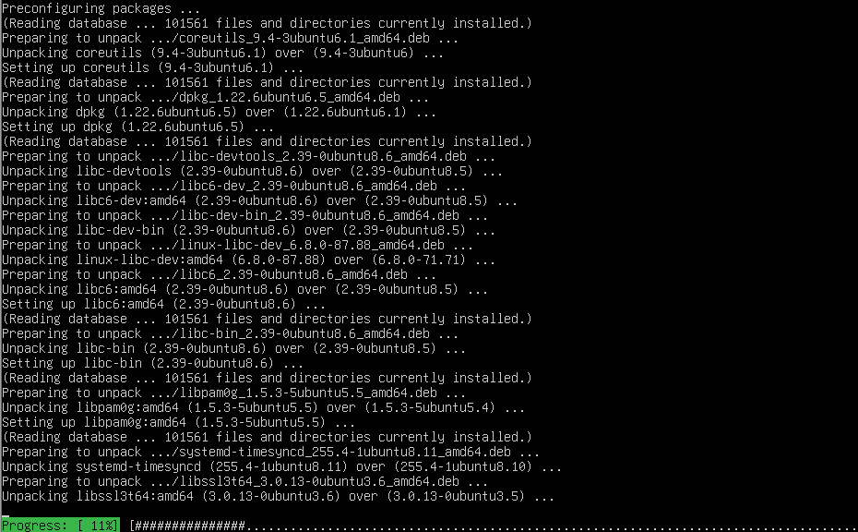
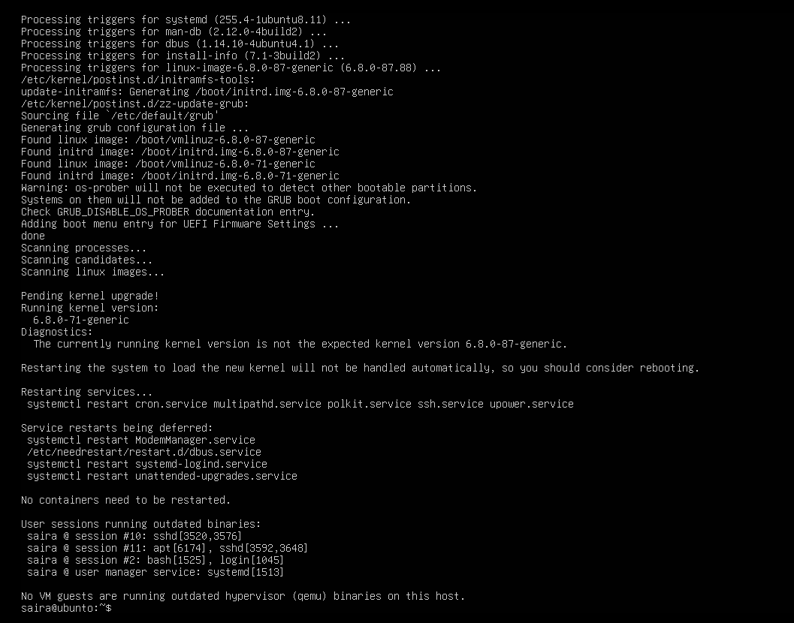
- Write a short 3–5 sentence explanation describing the difference between apt update and apt upgrade. Put your text into a small file and capture it as a screenshot (do not upload the text file; provide the screenshot):
nano ~/apt_update_vs_upgrade.md
# write 3-5 sentences, save and exit
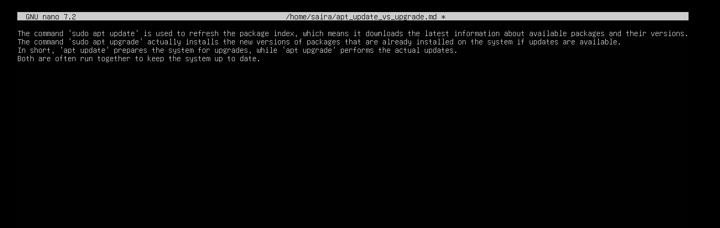
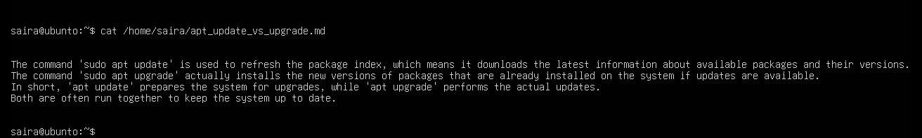
Task 4 - Install Visual Studio Code via snap on CLI and verify (DO NOT remove Code)
Goal: Install a snap package (example: VS Code) on a CLI-only server and verify installation using commands that work without a GUI. Keep Code installed for later GUI tasks.

Steps (inside VM terminal)
- Install VS Code via snap (snap may require sudo):
sudo snap install --classic code
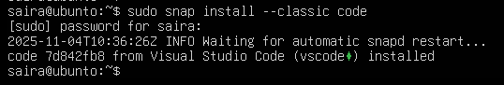
- Verify snap shows the package is installed:
snap list code
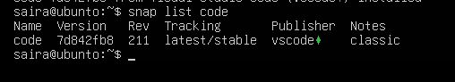
- Check the installed application's version. On some systems code --version is available; also check snap info:
code –version
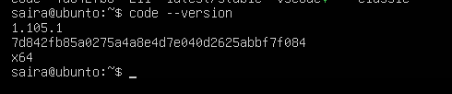
- If the code binary is not in PATH, show where the snap placed it:
ls -l /snap/bin | grep code
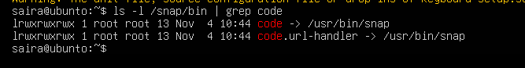
Task 5 - Install XFCE GUI + XRDP - minimal desktop and remote access (GUI) and launch VS Code
Goal: Install a lightweight GUI (XFCE), enable XRDP for remote desktop access, and learn how to control whether the GUI login screen appears at boot. After starting the GUI, launch the VS Code installed in Task 4 to verify GUI app launch. This task is for this lab.
Steps (inside the host terminal / via SSH)
- From your host, open your preferred terminal (for example: Windows Command Prompt, PowerShell, macOS Terminal, or Linux Terminal) and connect to the VM using SSH. Example:
ssh student@<vm-ip-address>
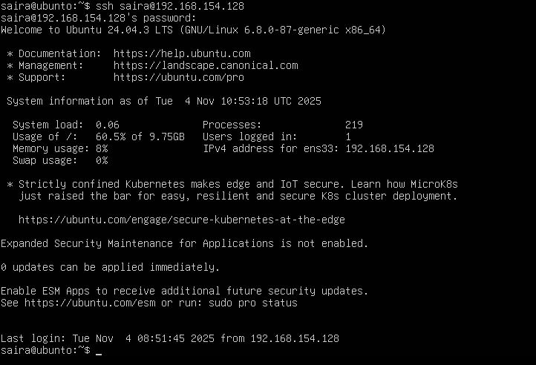
- Update the server (download package lists and apply upgrades):
sudo apt update && sudo apt upgrade –y
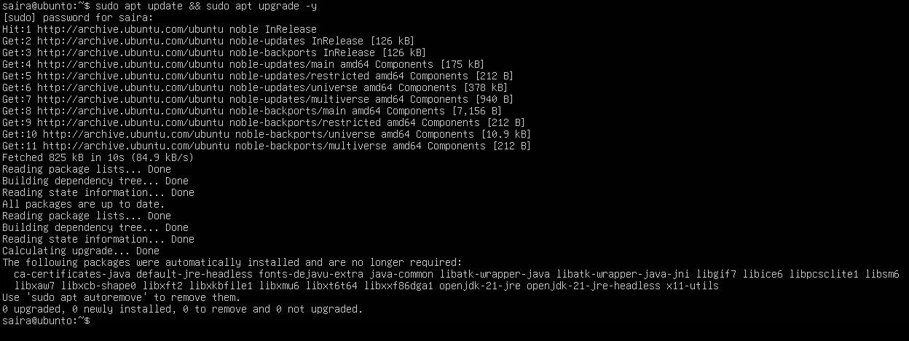
- Install XFCE and XFCE goodies (lightweight desktop):
sudo apt install xfce4 xfce4-goodies –y
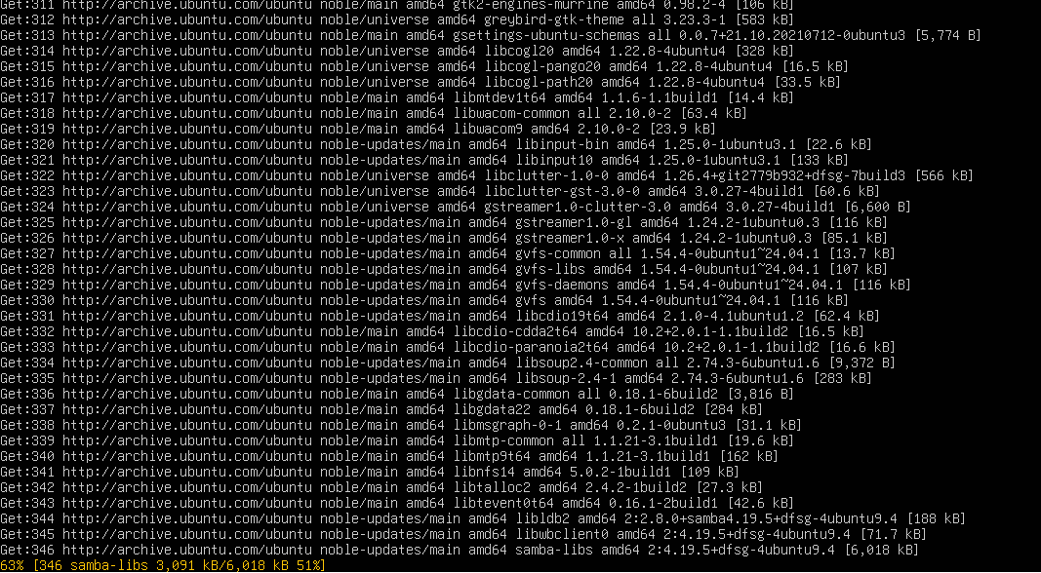
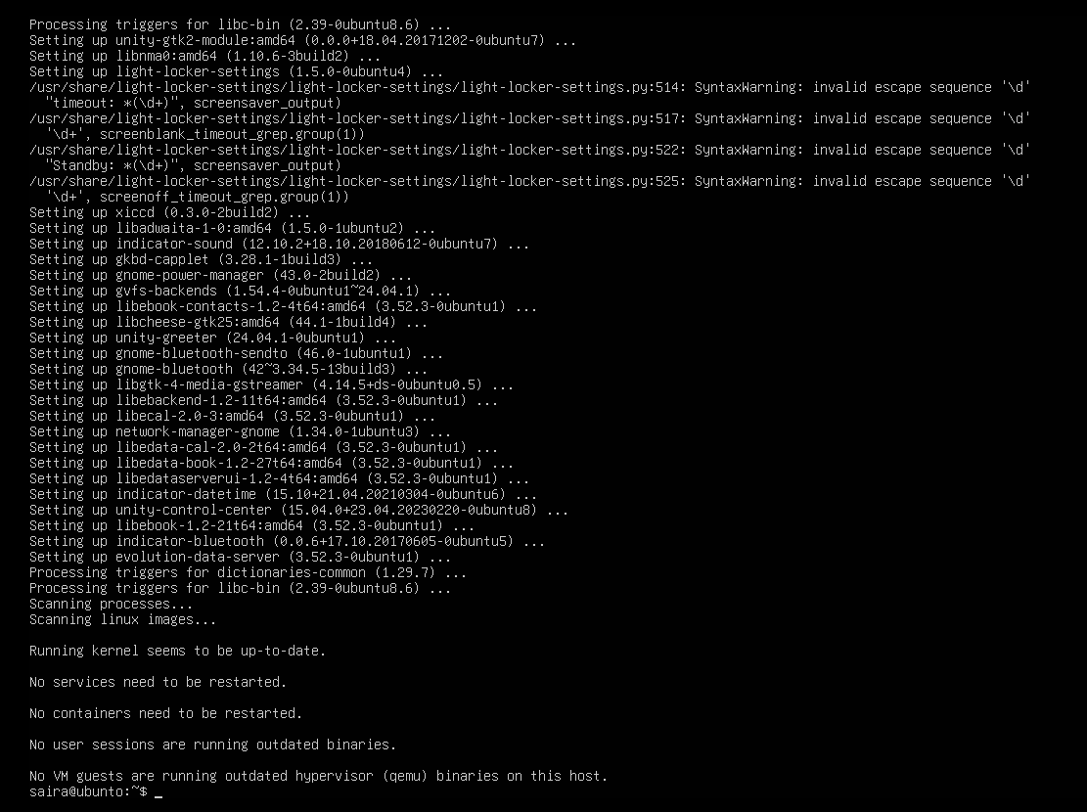
- Install and enable XRDP (Remote Desktop Protocol server):
sudo apt install xrdp –y
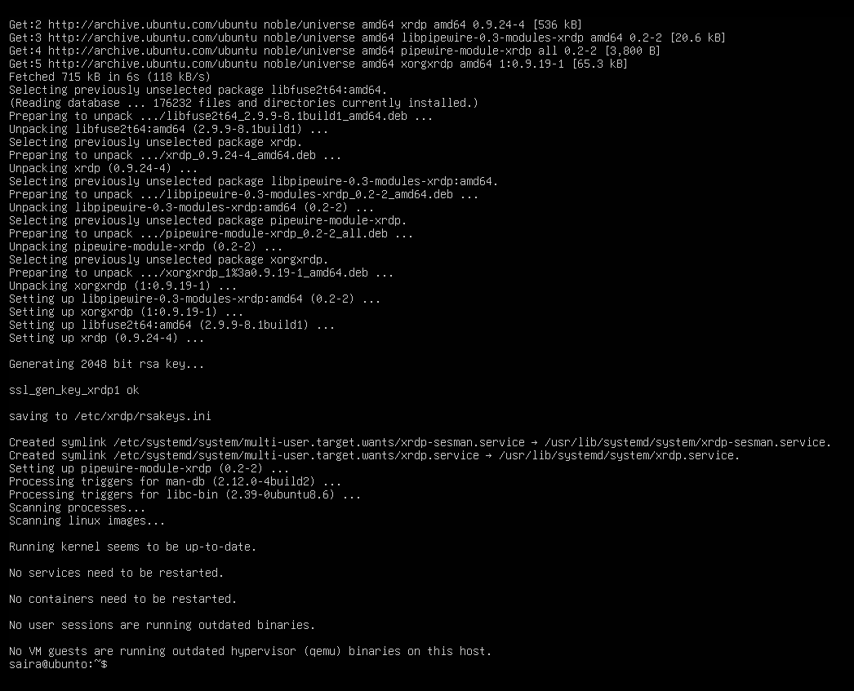
sudo systemctl enable --now xrdp
- Verify XRDP status:
sudo systemctl status xrdp
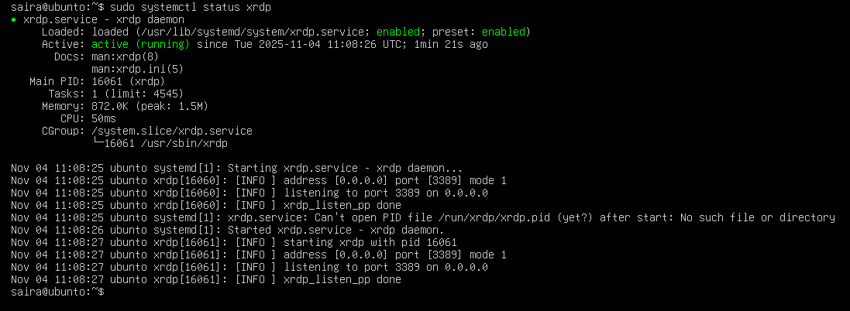
- Configure XRDP to use XFCE session:
echo xfce4-session > ~/.xsession
- From a Windows host or RDP client, connect with Remote Desktop (mstsc) to your server IP and login using your Ubuntu username/password. Capture a screenshot of the remote desktop or the RDP session window (if allowed by your environment) and save it as: task5_rdp_connect.png
If you cannot capture a screenshot from the client, show ss -ltnp or ps evidence that the session was established and save as an alternative.
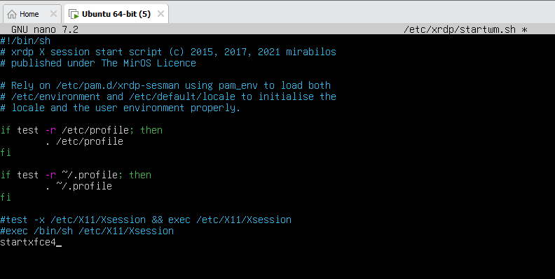
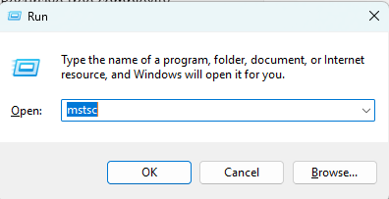
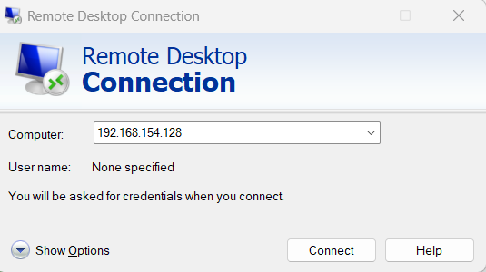
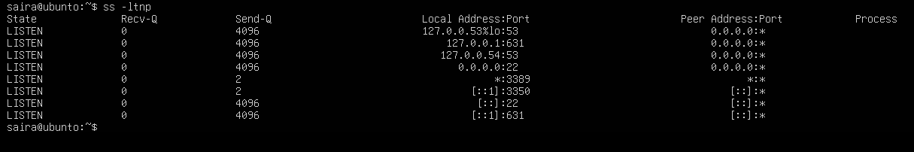
After you are in the GUI (local console or RDP session), launch Visual Studio Code (installed in Task 4) from the GUI menu or a terminal inside the GUI. Example command from a GUI terminal
Task 6 - Install lightdm-gtk-greeter and GUI verification - start GUI, open VS Code, take snapshot, then end (GUI)
Steps (inside the host terminal / via SSH)
- Fix GUI login screen issues (if lightdm / greeter problems appear)
Install LightDM and greeter using Host Terminal:
sudo apt install lightdm lightdm-gtk-greeter –y
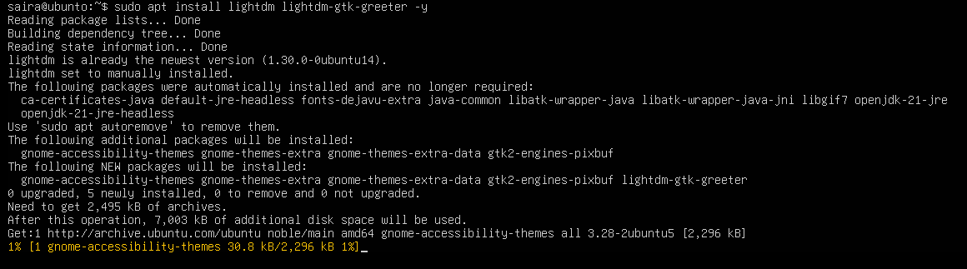
- Create LightDM config to use XFCE:
sudo mkdir -p /etc/lightdm/lightdm.conf.d
echo -e "[Seat:*]\ngreeter-session=lightdm-gtk-greeter\nuser-session=xfce\nautologin-user-timeout=0" | sudo tee /etc/lightdm/lightdm.conf.d/99-xfce.conf
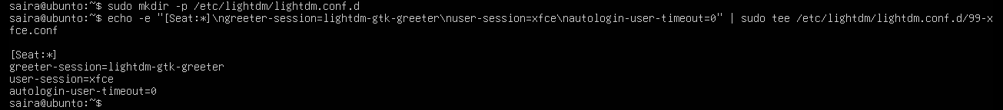
- Clean up problematic session files and permissions:
sudo rm -f /var/lib/lightdm/.Xauthority
sudo rm -f ~/.Xauthority
sudo rm -rf ~/.cache/sessions
sudo chown -R $USER:$USER /home/$USER
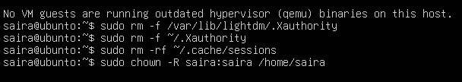
- Restart LightDM:
sudo systemctl restart lightdm
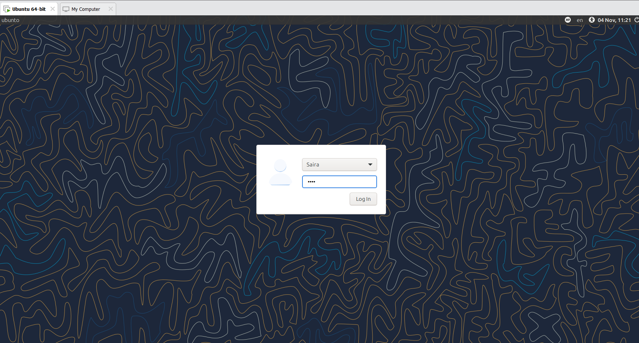
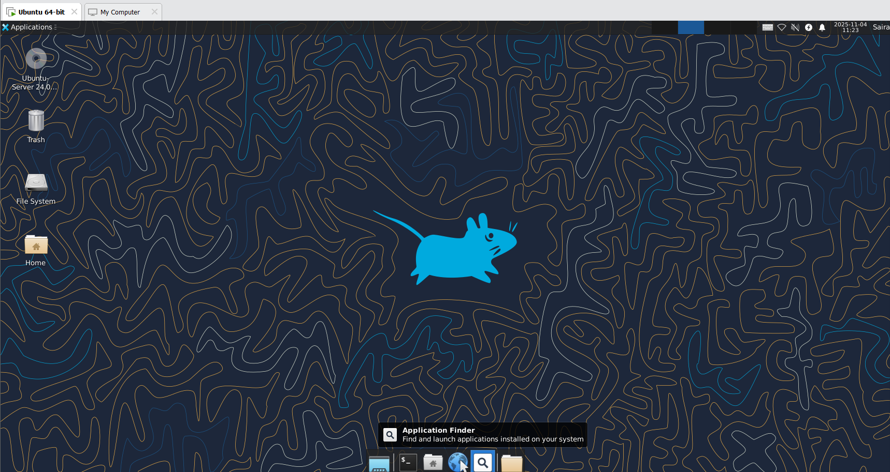
- Control GUI login at boot — ENABLE first, then DISABLE (observe and understand terminal/GUI behavior after each reboot)
Important: students MUST perform the reboot after each target change to observe the boot-time behavior. The sequence below has been adjusted so you ENABLE the GUI boot target first, reboot and observe GUI, then DISABLE the GUI boot target, reboot and observe the CLI.
- Enable GUI Login Screen (Boot to GUI)
- Re-enable LightDM and set the graphical target as default:
sudo systemctl enable lightdm
sudo systemctl set-default graphical.target
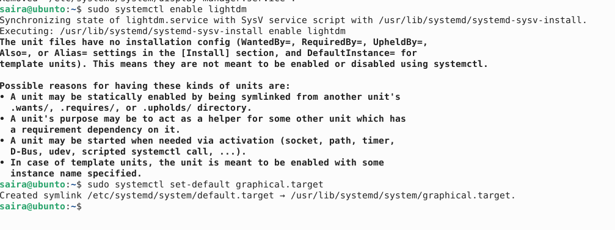
- Reboot the VM to observe that it boots to the GUI login screen:
sudo reboot
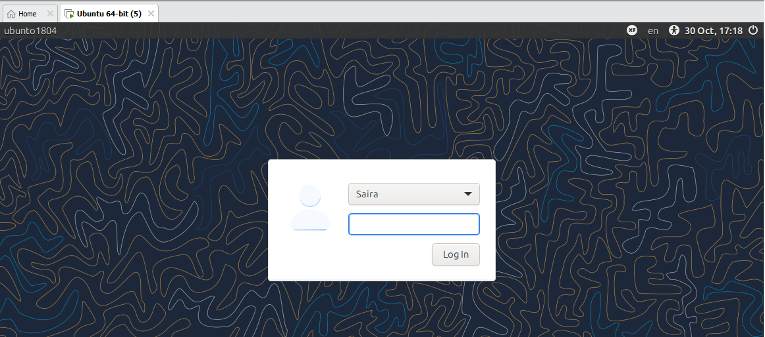
- Disable GUI Login Screen (Boot to CLI)
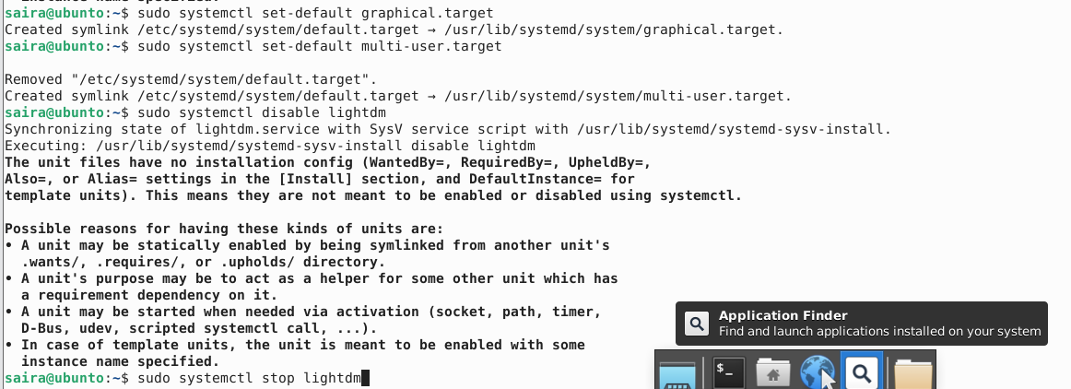
- Set the default boot target to multi-user (text mode) and disable LightDM so the system boots to the terminal:
sudo systemctl set-default multi-user.target
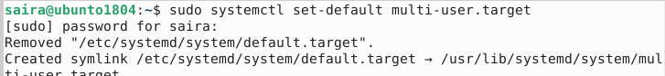
sudo systemctl disable lightdm
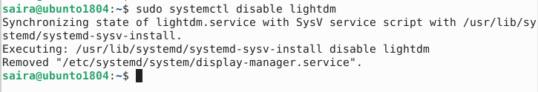
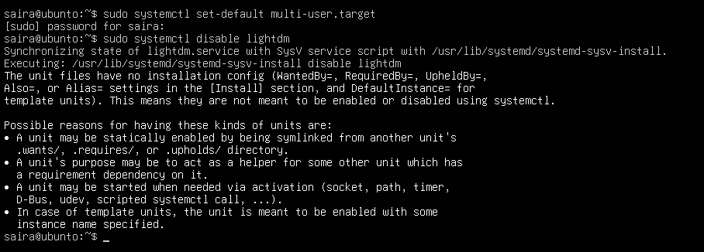
- Reboot the VM to observe that it boots to the terminal (CLI):
sudo reboot
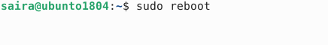
- Start/Stop GUI manually (no reboot)
You can start the GUI session without changing the boot target. This is useful if you want to keep the boot target as CLI but run GUI temporarily:
sudo systemctl start lightdm # start GUI now
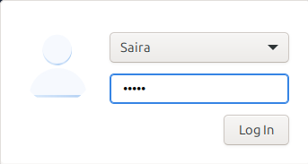
- Press Ctrl + Alt + F3 to switch back to TTY. You can stop the GUI session without changing the boot target.
sudo systemctl stop lightdm # stop GUI now
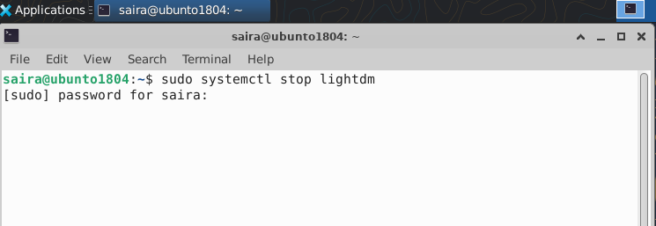
- Start the GUI (if the system is currently set to CLI or the GUI is not running):
sudo systemctl start lightdm
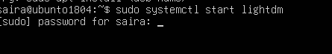
- In the GUI session launch Visual Studio Code (installed earlier in Task 4). From a GUI terminal inside the desktop, run:
Code
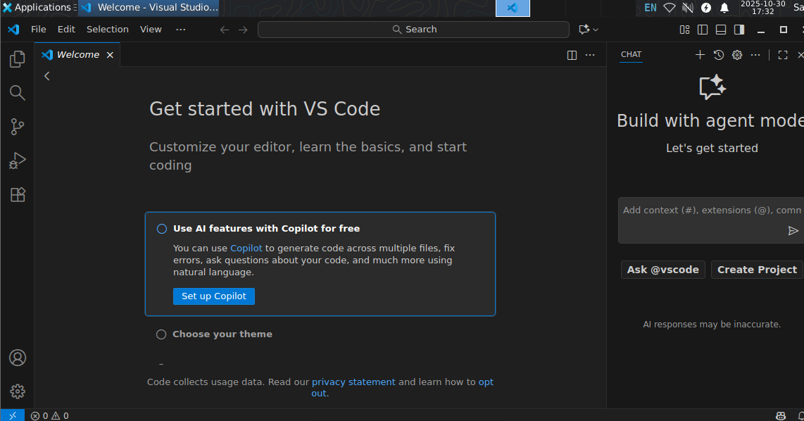
Task 7 - Install Google Chrome by adding its apt source & key (Chrome)
Steps (inside the VM terminal or GUI terminal or host terminal / via SSH)
- (Learning step — first command must be the install attempt) Attempt to install Google Chrome directly to see the failure when the repo/key are missing:
sudo apt install google-chrome-stable –y
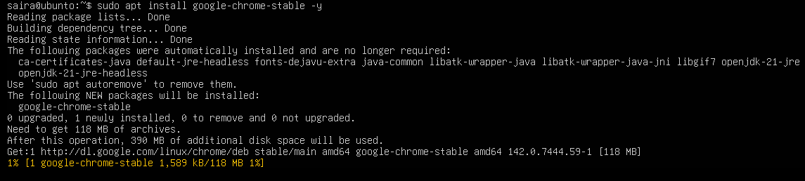
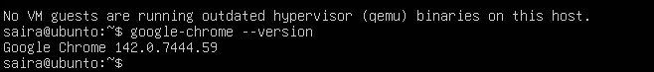
Expected: this will typically fail with "Unable to locate package google-chrome-stable" or similar because the Google repo/key are not yet configured.
- Inspect apt configuration so you understand why install failed. List the /etc/apt directory:
ls -la /etc/apt
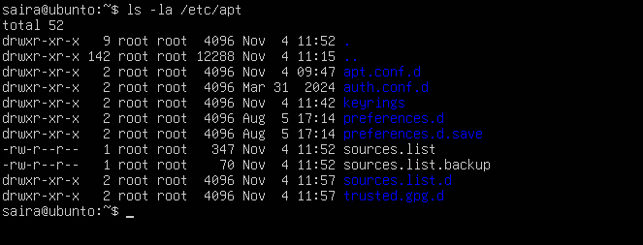
- View the main /etc/apt/sources.list:
cat /etc/apt/sources.list
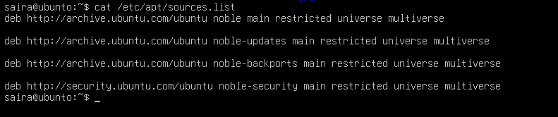
- List files under /etc/apt/sources.list.d:
ls -la /etc/apt/sources.list.d/
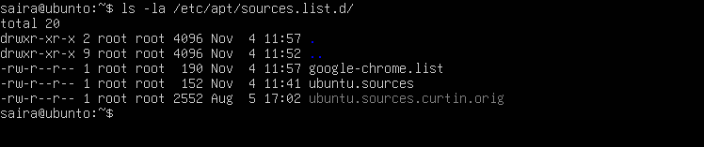
- If there is a file named ubuntu.sources (or similarly named source file), display it to see whether Chrome's repo is present:
cat /etc/apt/sources.list.d/ubuntu.sources
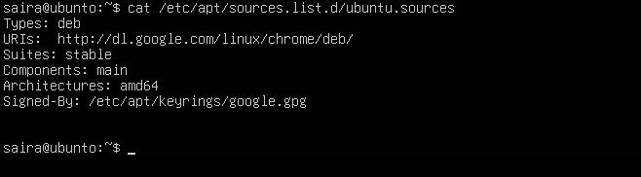
- Add Chrome repository metadata to a sources file (method A — using ubuntu.sources). Open or create the file and append the stanza (you can alternatively use the preferred one-line method in step 11):
sudo nano /etc/apt/sources.list.d/ubuntu.sources
Append these exact lines at the end of the file:
Types: deb
URIs: http://dl.google.com/linux/chrome/deb/
Suites: stable
Components: main
Architectures: amd64
Signed-By: /etc/apt/keyrings/google.gpg
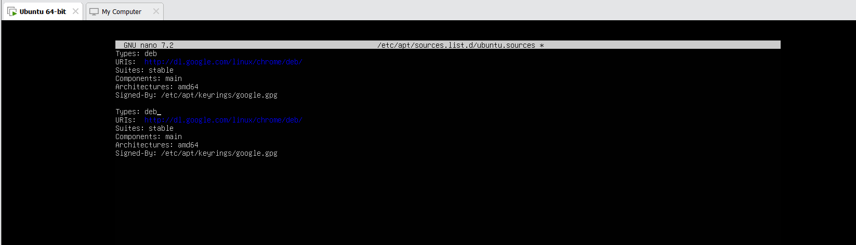
- Ensure the keyrings directory exists and import Google's signing key:
curl -fsSL https://dl.google.com/linux/linux_signing_key.pub | sudo gpg --dearmor -o /etc/apt/keyrings/google.gpg
- Update apt and attempt to install Chrome again (now that repo + key are added):
sudo apt update
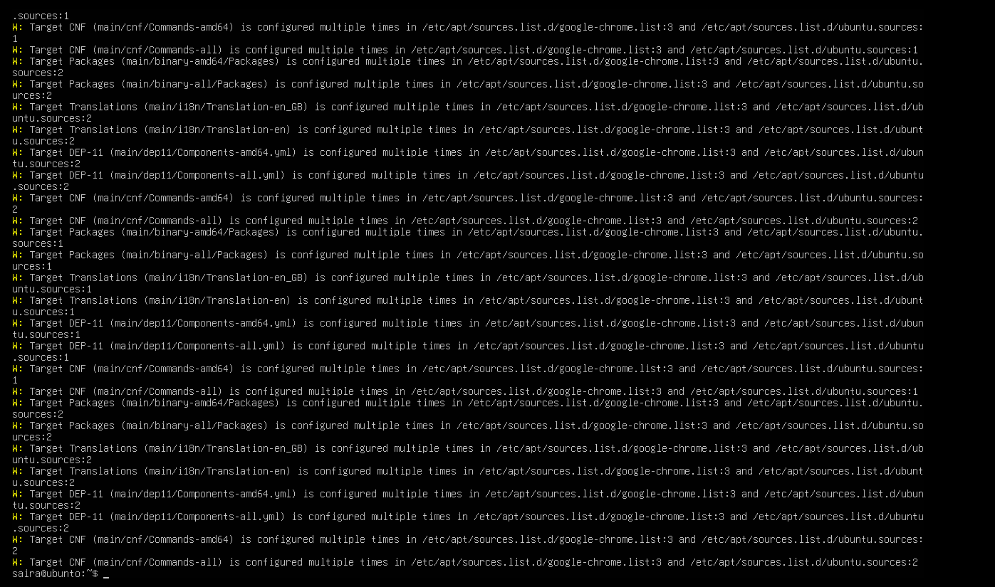
sudo apt install google-chrome-stable -y
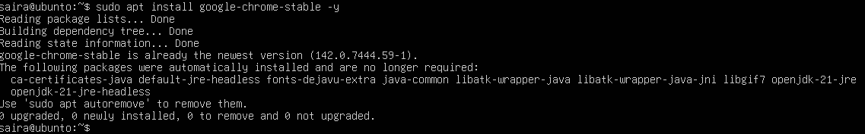
- Alternate (preferred, cleaner) method — create a single google-chrome.list entry
Cleanup before alternate method you added the chrome earlier and want to switch to the preferred method:
sudo apt remove google-chrome-stable -y
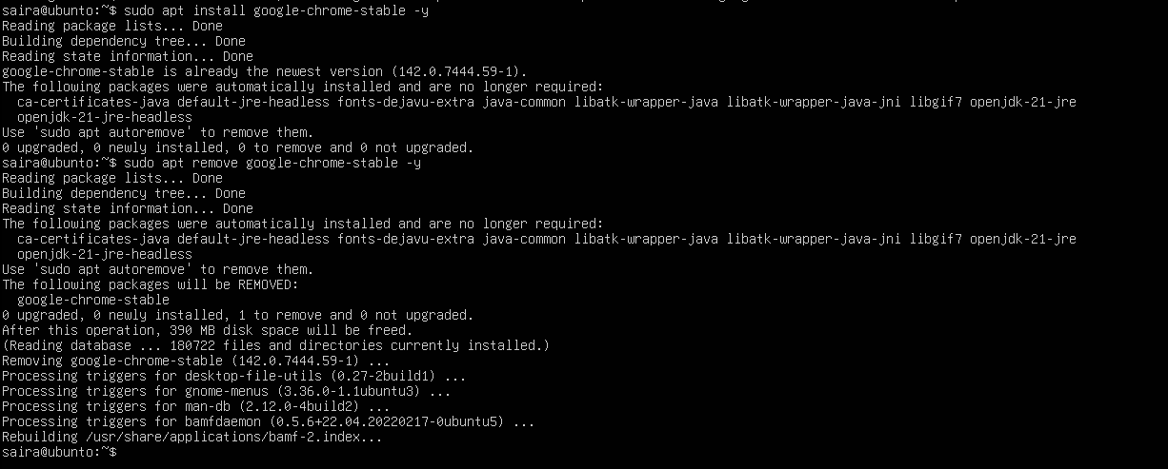
sudo nano /etc/apt/sources.list.d/ubuntu.sources # remove the chrome stanza you added earlier, save and exit
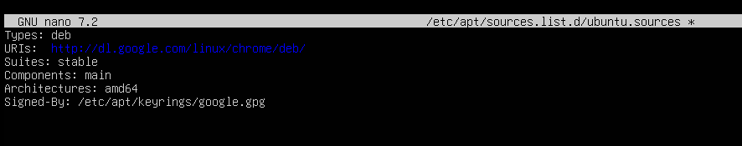
sudo rm -f /etc/apt/keyrings/google.gpg
- Create a dedicated one-line list file for Google Chrome (preferred):
echo "deb [arch=amd64 signed-by=/etc/apt/keyrings/google.gpg] http://dl.google.com/linux/chrome/deb/ stable main" | sudo tee /etc/apt/sources.list.d/google-chrome.list > /dev/null
- Verify the new file exists:
ls -la /etc/apt/sources.list.d/
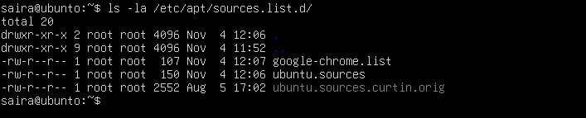
- Re-add the Google signing key (if removed previously or not present):
sudo mkdir -p /etc/apt/keyrings
curl -fsSL https://dl.google.com/linux/linux_signing_key.pub | sudo gpg --dearmor -o /etc/apt/keyrings/google.gpg
- Update apt and install Chrome (preferred flow):
sudo apt update
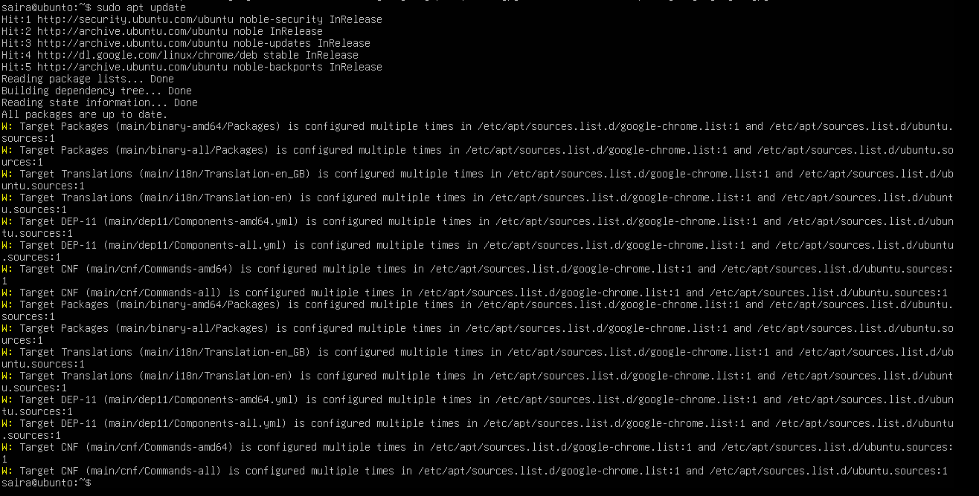
sudo apt install google-chrome-stable -y
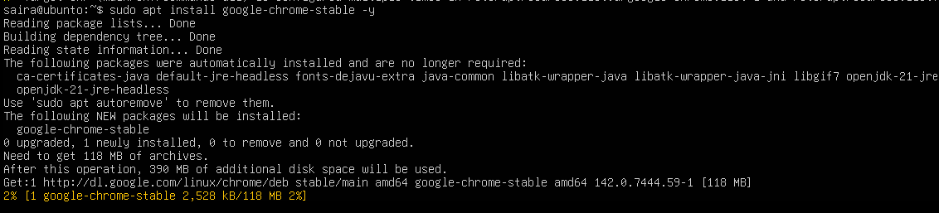
Task 8 - Install applications via PPA (Audacity & OBS) and launch
Goal: Add PPAs for Audacity and OBS Studio, update apt, install the packages, and launch them (or verify installation) from the CLI/GUI. Capture screenshots for each step.
Steps (inside the VM terminal or GUI terminal)
- Add the Audacity PPA, update apt and install audacity:
sudo add-apt-repository ppa:ubuntuhandbook1/audacity -y
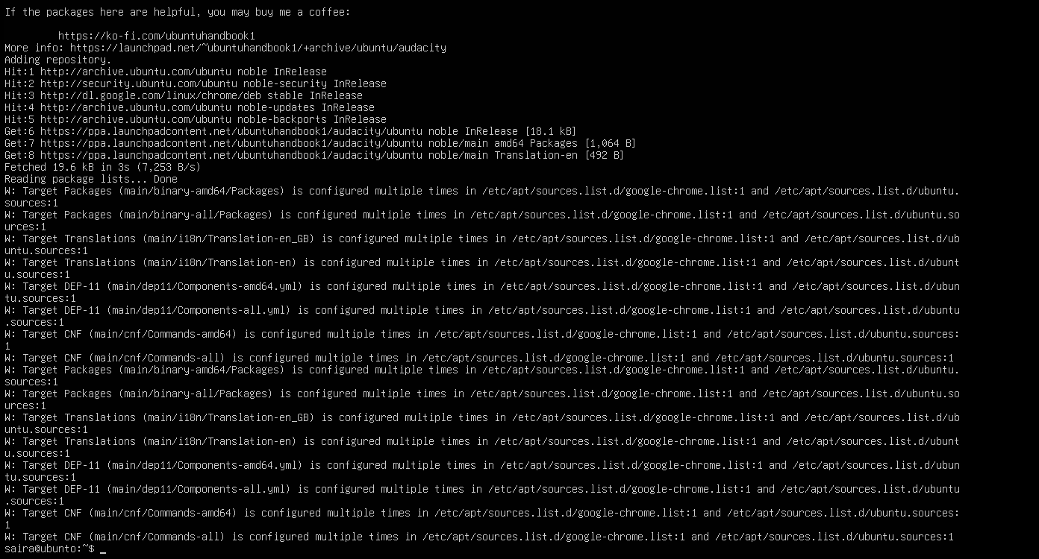
sudo apt update
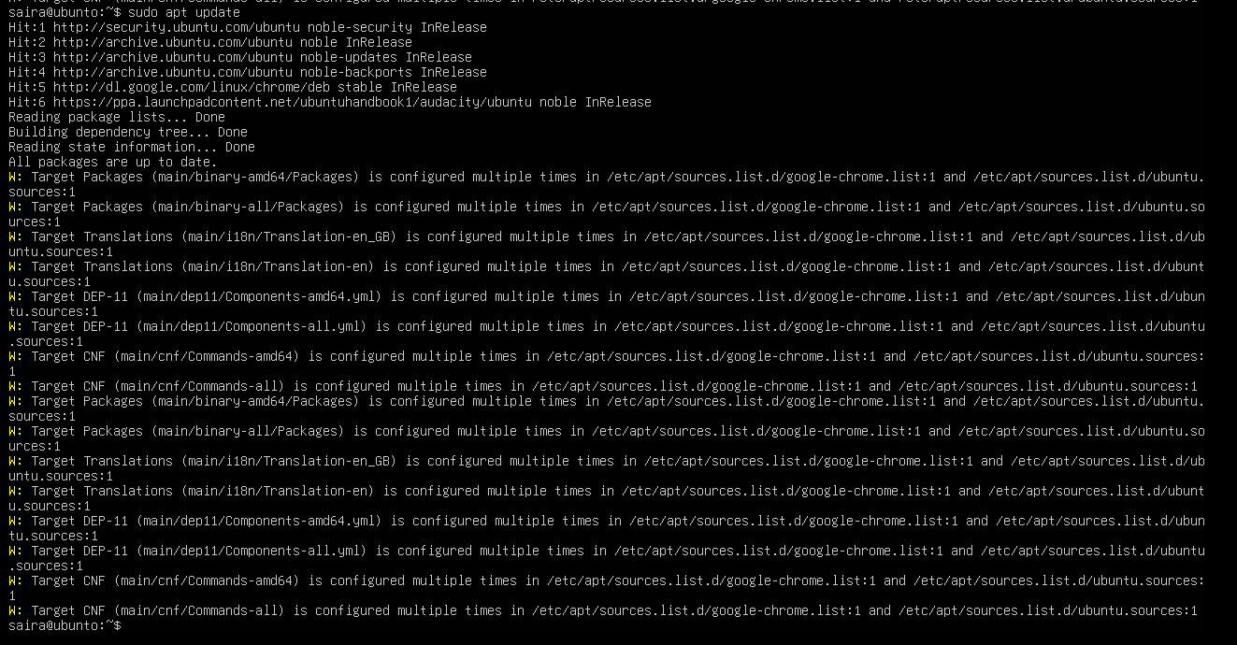
sudo apt install audacity -y
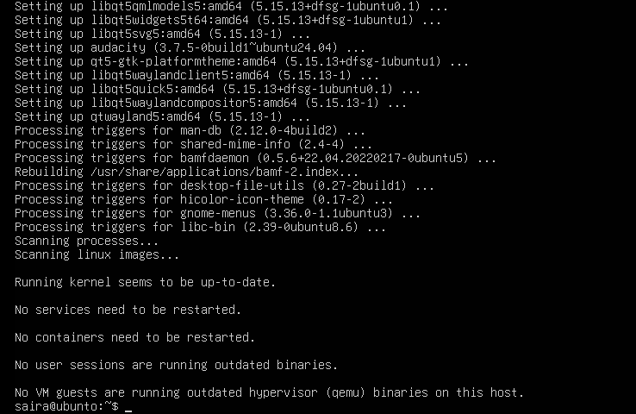
- Launch Audacity (from GUI or CLI). On a headless server you may not get a GUI window — if you are using the XFCE GUI session, launch from a GUI terminal or run check for binary:
audacity --version
audacity
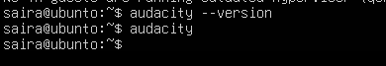
- Add the OBS Studio PPA, update apt and install obs-studio:
sudo add-apt-repository ppa:obsproject/obs-studio -y
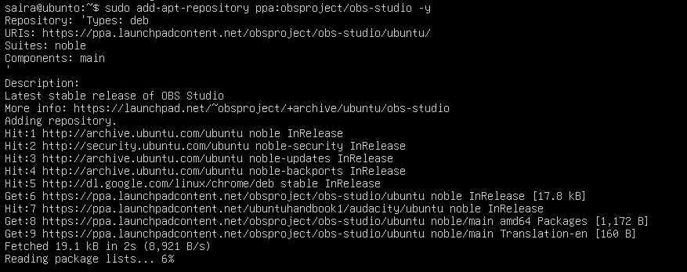
sudo apt update
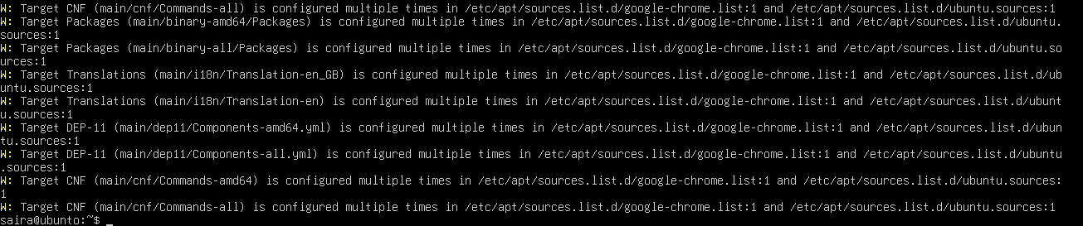
sudo apt install obs-studio -y
- Launch OBS Studio (from GUI or verify binary presence):
obs --version
obs
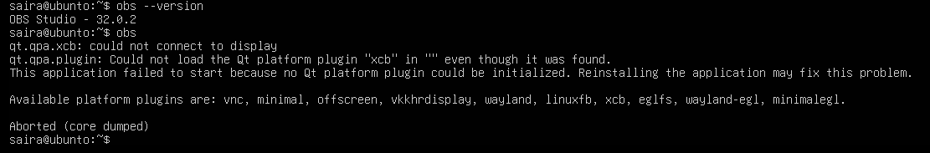
Task 9 - Create a Kubernetes sample YAML using vim
Goal: Confirm vim availability, create a working directory for Lab5, and use vim to create and save a Kubernetes Pod manifest named k8s-sample.yaml.
Steps (inside the VM terminal or host terminal / via SSH)
- Check whether vim is installed by running:
vim
- If vim opens, you will see the vim interface; if not installed you will see a command-not-found error.
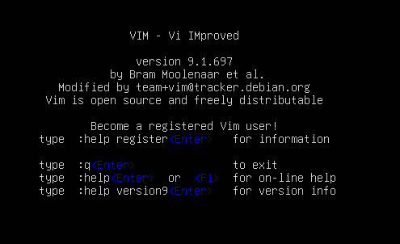
- If vim is not installed, install it:
sudo apt update
sudo apt install vim -y
- Create the Lab5 working directory in your home and change into it:
mkdir -p ~/Lab5
cd ~/Lab5
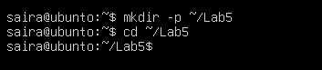
- Create the Kubernetes sample file using vim:
vim k8s-sample.yaml
- Once vim opens, enable insert mode by pressing i, then paste the following YAML exactly:
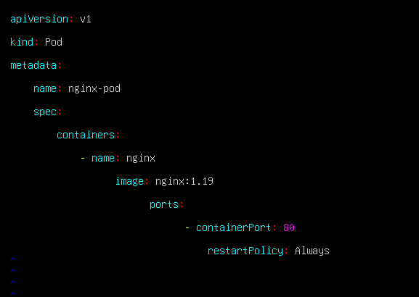
- Exit insert mode by pressing Esc, then save and quit vim with:
:wq
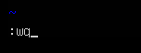
Task 10 - Edit the Kubernetes YAML - add annotation, verify, then discard temporary change
Steps (inside the VM terminal or host terminal / via SSH)
- Open the manifest with vim:
cd ~/Lab5
vim k8s-sample.yaml
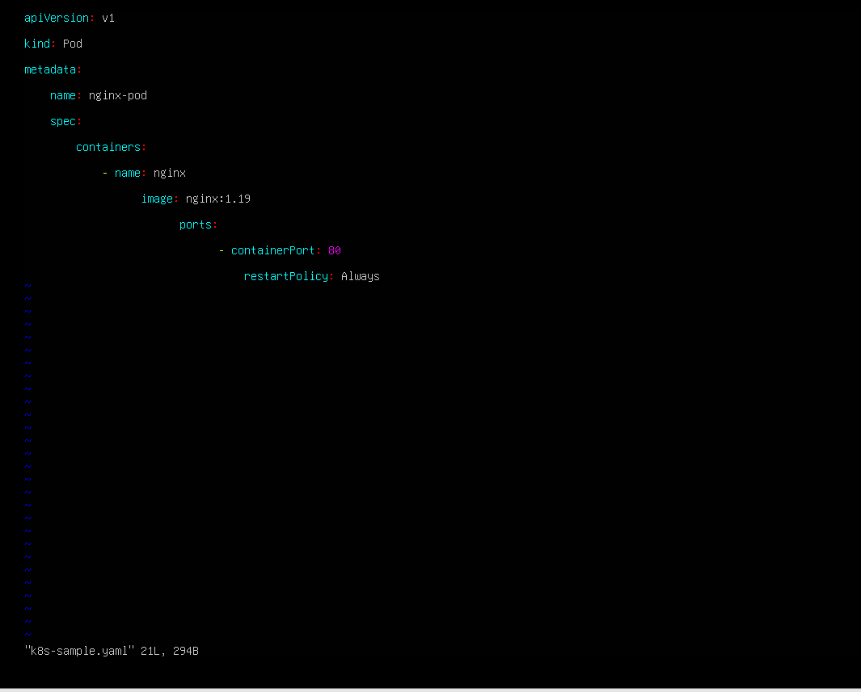
- Add the annotation under the metadata section (indentation must match YAML). Example (insert these lines under metadata:):
annotations:
lab: lesson11
- After adding the lines, press Esc to return to command mode and save & quit:
:wq
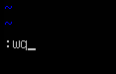
Example verify command:
cat k8s-sample.yaml
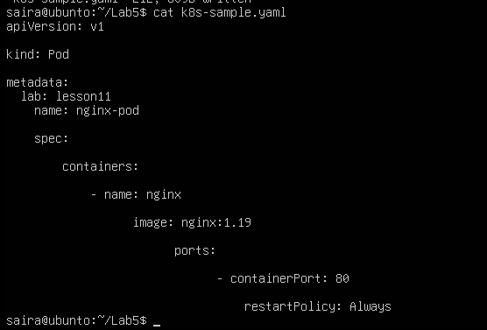
- Discard changes (practice: make a temporary edit and exit without saving)
- Open the file again:
vim k8s-sample.yaml
- Enter insert mode (i) and add a temporary comment line anywhere, for example:
# temp: do-not-keep
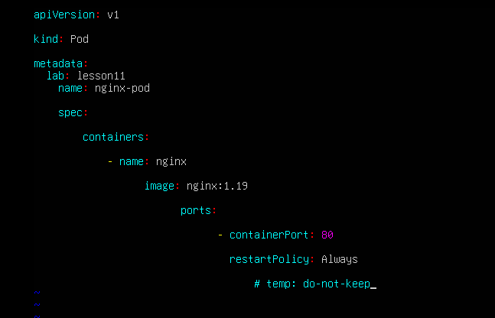
- Do NOT save. Press Esc to go back to command mode, then force quit without saving:
:q!
- Verify the file does NOT contain the temporary comment:
cat k8s-sample.yaml
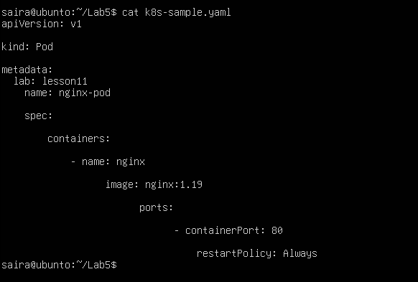
Task 11 - Vim editing practice - delete, undo, numeric deletes, navigation
Steps (inside the VM terminal or host terminal / via SSH)
- Open the file with vim:
cd ~/Lab5
vim k8s-sample.yaml
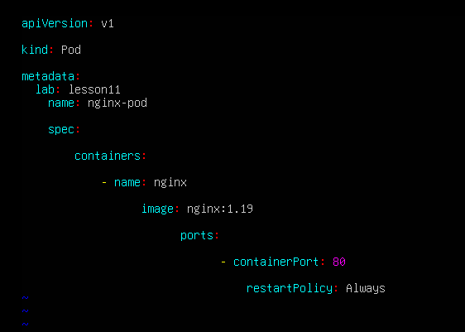
- Delete the line containing image: nginx:1.19 with a single command:
- Ensure you are in command mode (press Esc), move the cursor to the line with image: nginx:1.19, then delete that line with:
dd
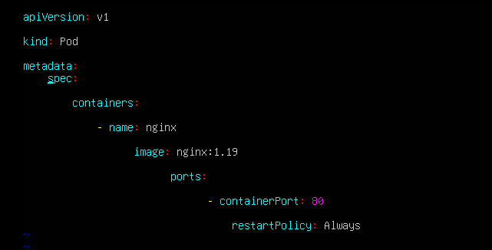
- Immediately undo the deletion with:
u
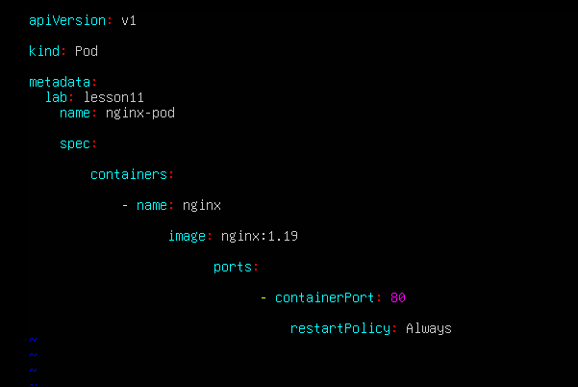
- Delete 3 lines at once using the numeric delete command:
- In command mode, position the cursor on the first line of the three you want to delete (for example start at the image: line again), then run:
d3d
(or 3dd or d3<enter> — either numeric prefix form is acceptable; document which you used)
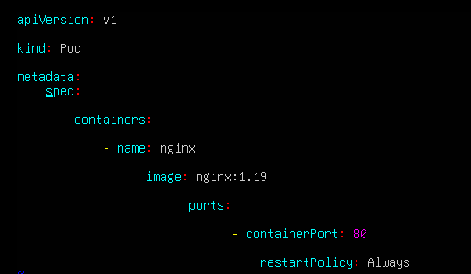
- Immediately undo the deletion with:
u
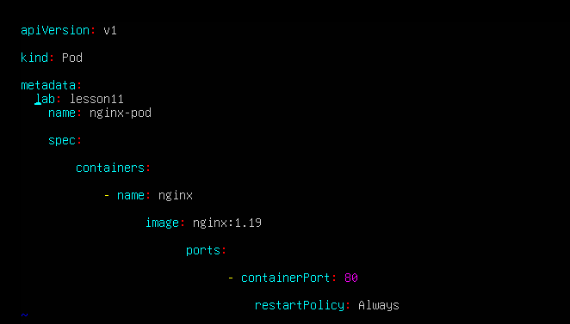
- Navigation practice (from command mode)
- Jump to the first line:
1G
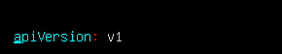
- Jump to the last line:
G
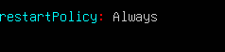
- Exit vim (no changes should remain if you undid properly):
:q
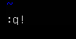
Task 12 - Vim search, add matches, substitute, undo.
Steps (inside the VM terminal / in the ~/Lab5 directory)
- Open the file with vim:
cd ~/Lab5
vim k8s-sample.yaml

- Search for the string nginx using the forward search command:
- From command mode type:
/nginx
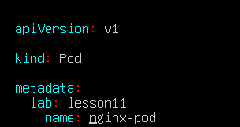
- Move to the next match and previous match:
- Press n to jump to the next match (capture screenshot if desired) and press N to jump back to the previous match.
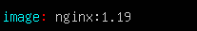
- Add two more occurrences of the word nginx in the file:
- Enter insert mode (i) at an appropriate place (for example add two new comment lines or add them under metadata as comments), type two new occurrences of nginx, then press Esc to return to command mode and save the file with :w.
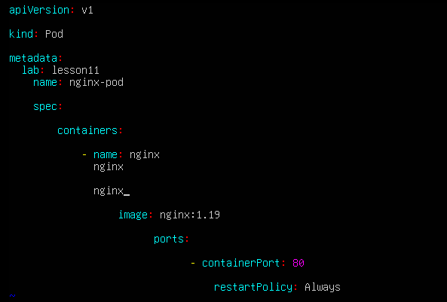
- Demonstrate that n cycles forward through all matches:
- In vim command mode press /nginx Enter, then repeatedly press n to cycle forward through each match.
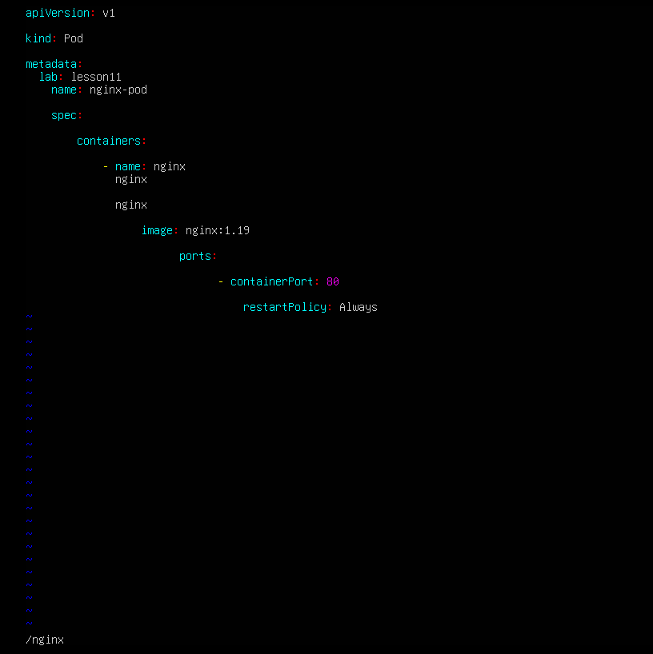
- Substitute all occurrences of nginx with webapp:
- From command mode execute the substitute command:
:%s/nginx/webapp
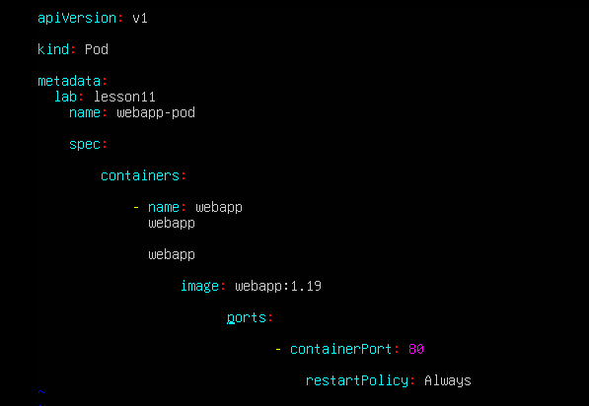
- Immediately undo the substitution using u:
- Press u in command mode to undo the last change.
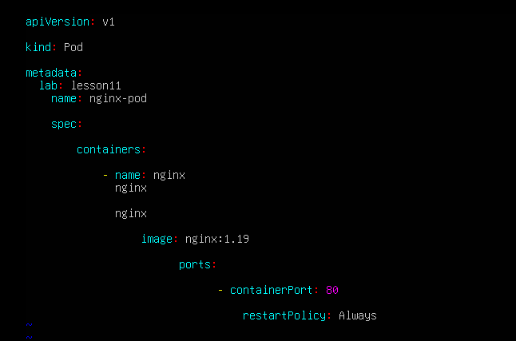
- Quit vim without saving any accidental changes (if you didn't already save after substitution and want to discard):
- If you want to ensure no changes were written, exit with:
:q!
- If you intentionally saved the substitution and then undid it and wish to quit normally, use :q

